PRACTICAL NO. 06

6. Configure IOS Intrusion Prevention System (IPS) Using the CLI
Topology :
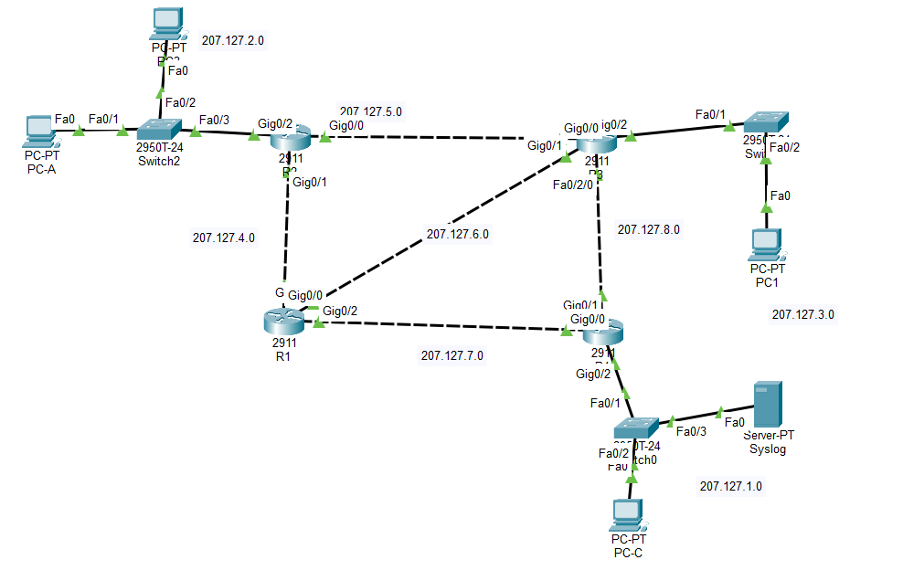

create a directory in flash using the mkdir command

Configure the IPS signature storage location

Create an IPS rule.

Enable logging.


Configure IOS IPS to use the signature categories.
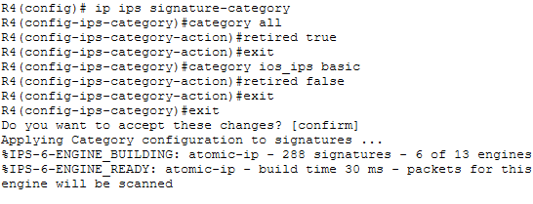

Apply the IPS rule to an interface.
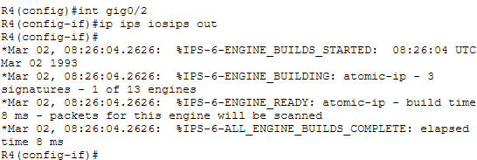

Change the event-action of a signature.
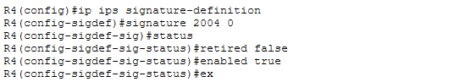
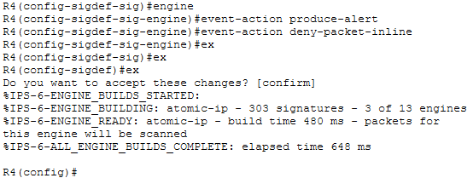

Verify that IPS is working properly by ping from PC-A to PC-C which should fails
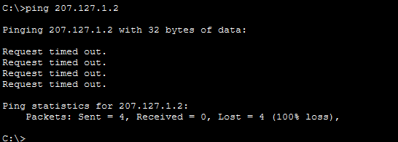

Verify that IPS is working properly by ping from PC-C to PC-A which should successful
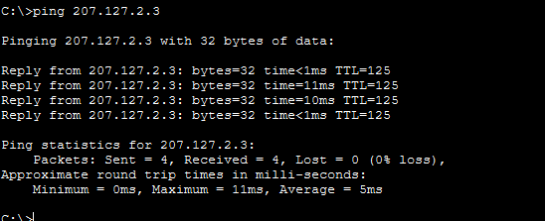

View the syslog messages.
